**Jenkins Maven Project With Email with Attachmen**

**Project Configuration**

1. [Selenium_FrameWork_Training_Maven](http://localhost:8080/job/Selenium_FrameWork_Training_Maven/) – Is the Project

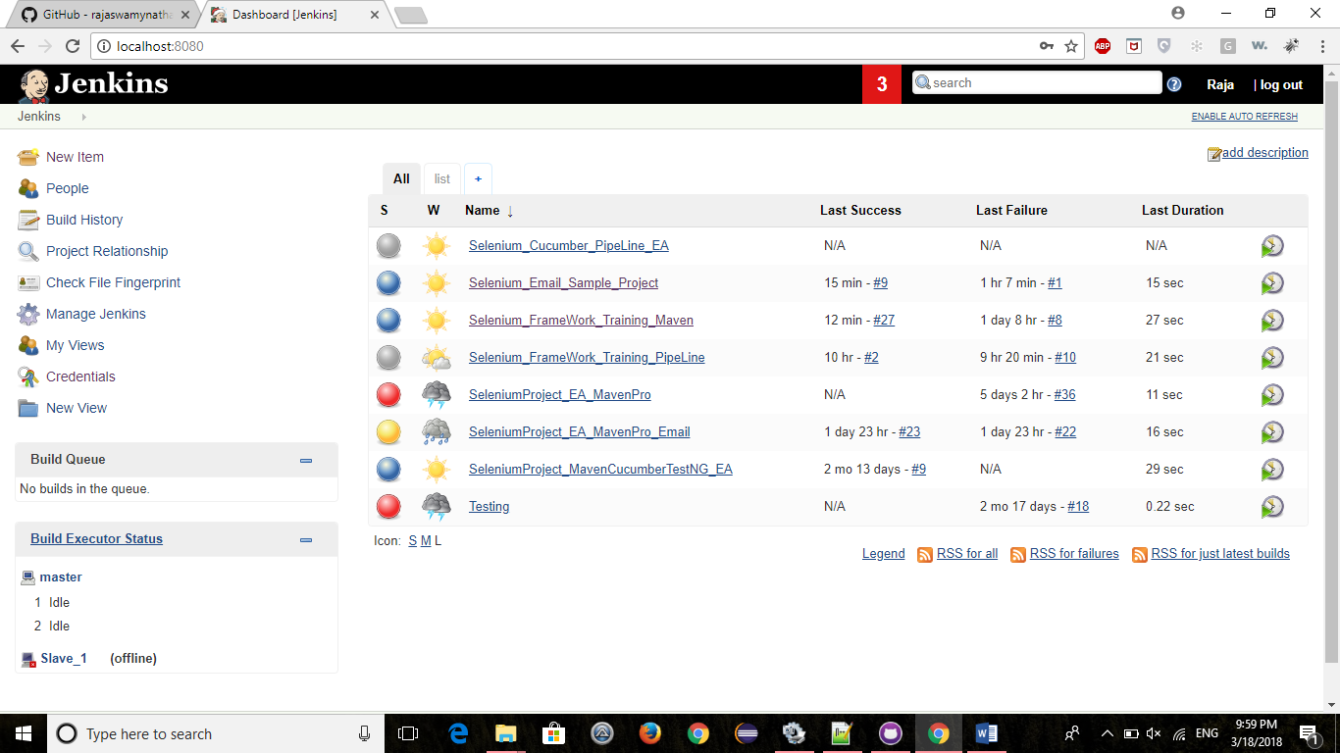

1. Goto “[Selenium_FrameWork_Training_Maven](http://localhost:8080/job/Selenium_FrameWork_Training_Maven/)” Project🡪 Configuration and goto Build section.
2. Enter the absolute Path of pom.xml file in RootPOM text box
3. Enter maven goals in Goals and Options text box

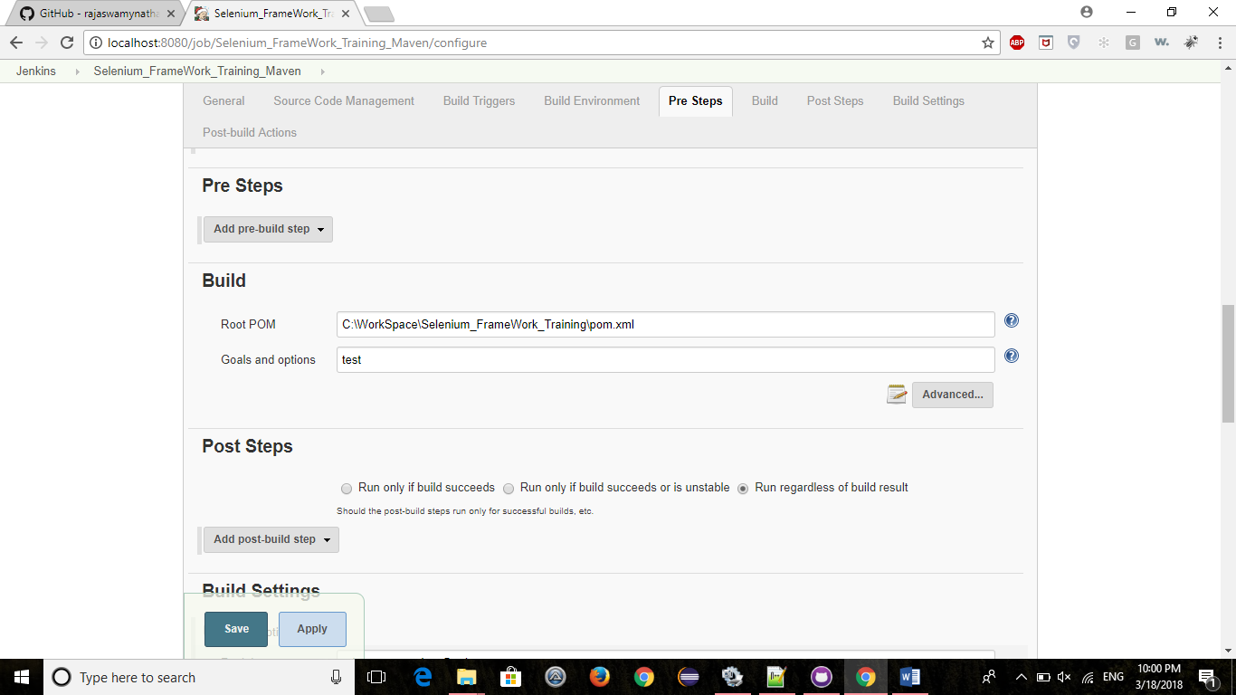

1. Goto Build Settings section and Enter email id in recipient text box
2. Select appropriate CheckBoxes like below

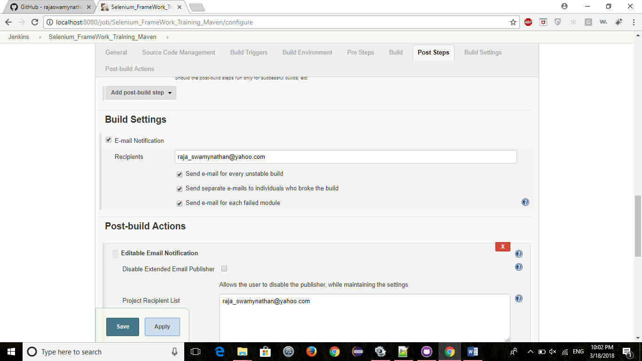

1. Got Post-build Actions 🡪 Editable Email Notification section
2. Enter email id in Project Recipient box & Project Reply-To List.
3. Enter appropriate values into Content-Type,Default Subject & Default Content

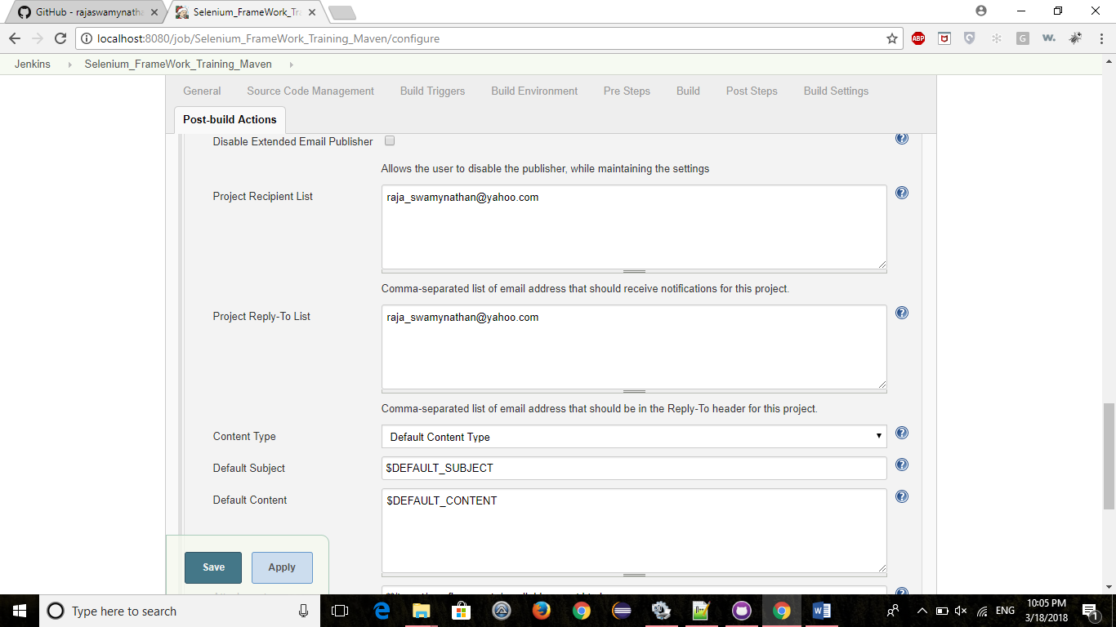

1. Enter the relative path to workspace folder

For Example : C:\WorkSpace\Selenium_FrameWork_Training –> WorkSpace

Attachments : **/target/surefire-reports/emailable-report.html -> It will attach emailable-report.html from -- > C:\WorkSpace\Selenium_FrameWork_Training/target/surefire-reports/emailable-report.html

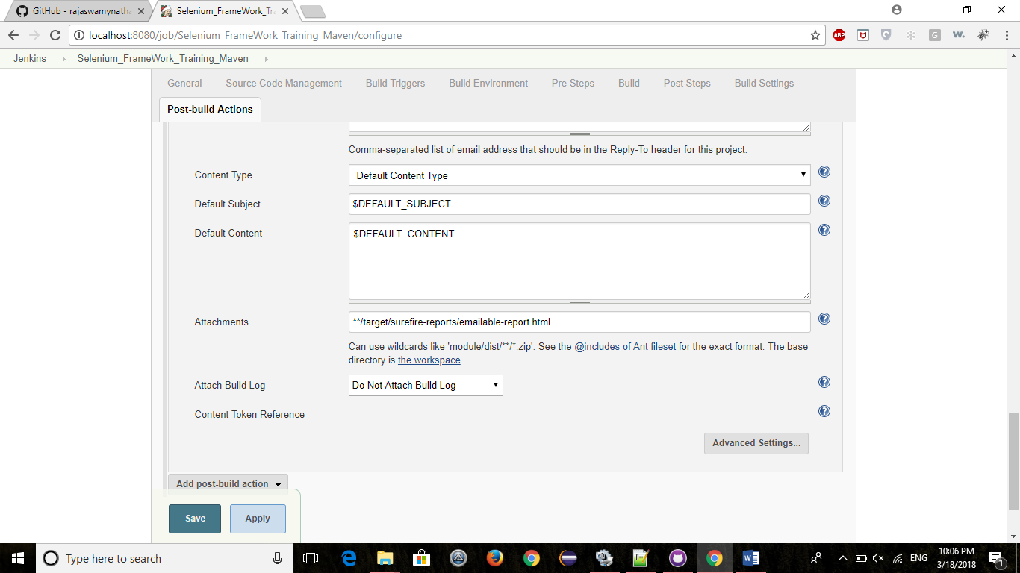

1. Important Settings :

Goto Editable Email Notification 🡪 goto Triggers section 🡪 click on Add Trigger and select “Always” option.

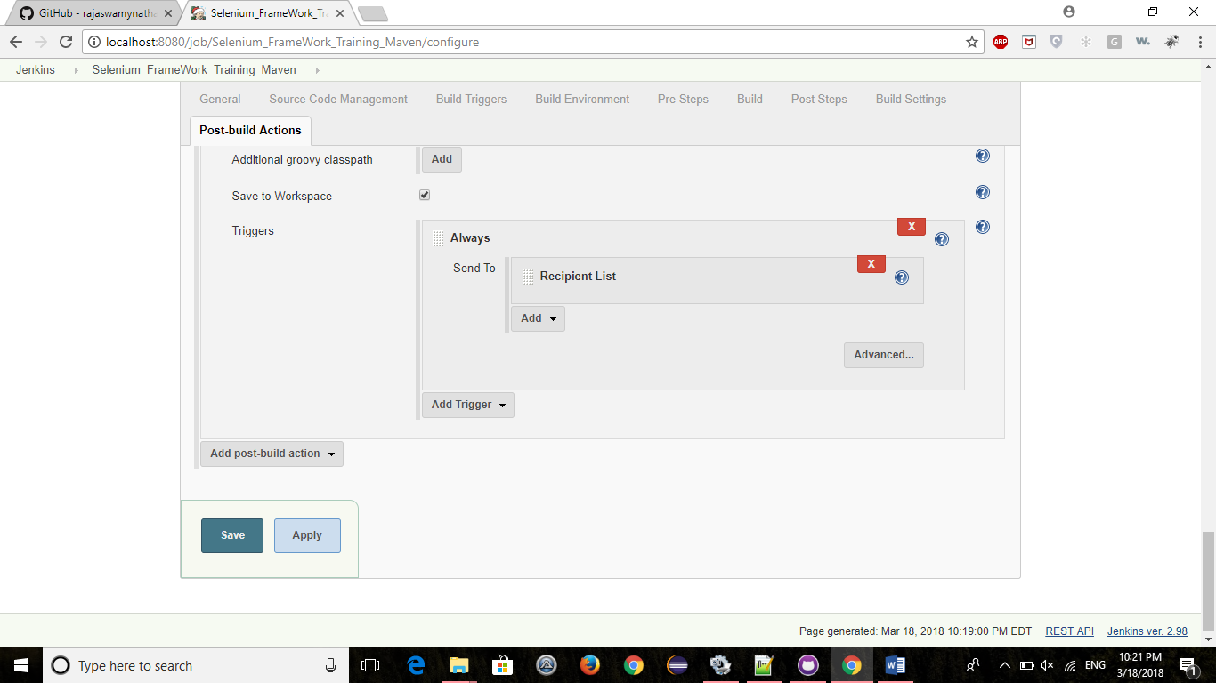

1. Make Sure that Always is displayed like the above picture.
2. Click on Advanced button here..
3. **Enter recipient email id 2 times separated by comma**.(If one email id only exists here then no email will be sent)
4. Enter attachment files path here too.
5. Click on Save & Apply button.
6. This settings are enough to send mail with attachment after each build.

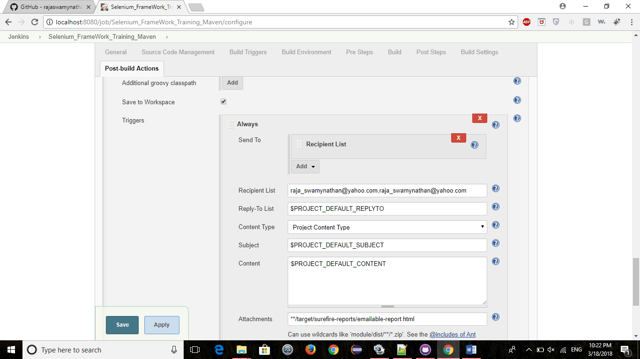

**Jenkins Configuration**

1. Goto Jenkins->Configuration->Configure System

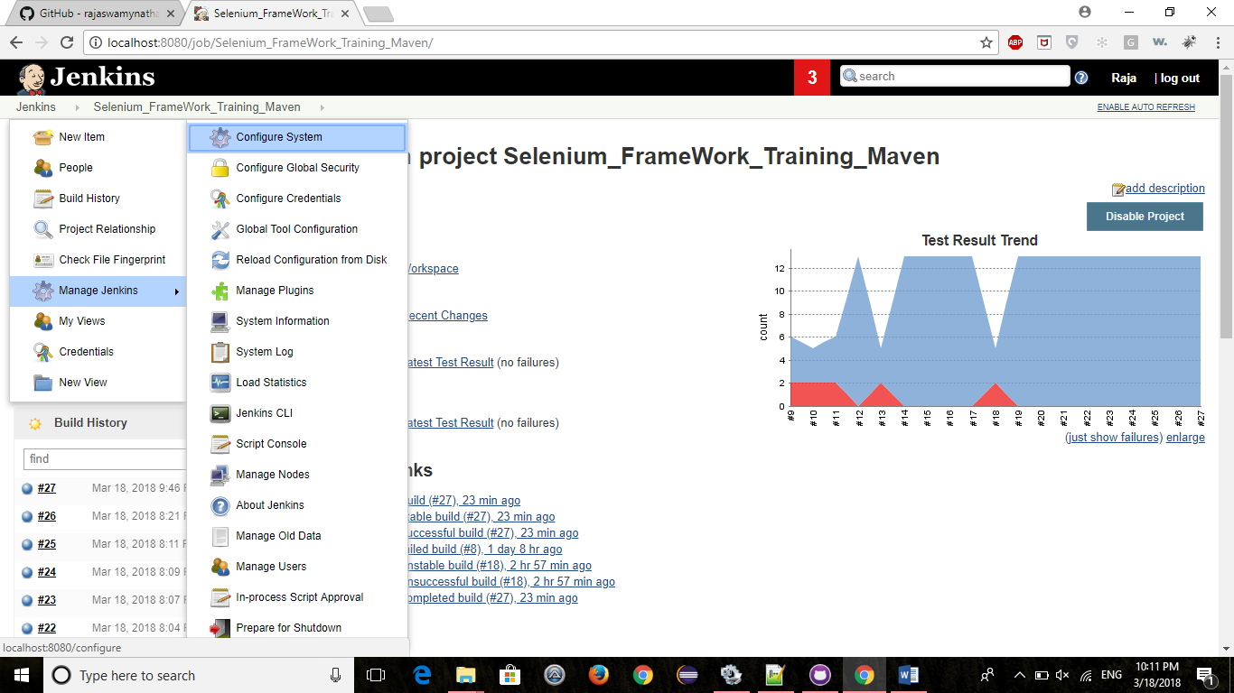

1. Goto Jenkins Location and enter System Email Address (This is the address from which mail will be sent). In this case , this is gmail address since we are going to use gmail smtp as smtp.gmail.com

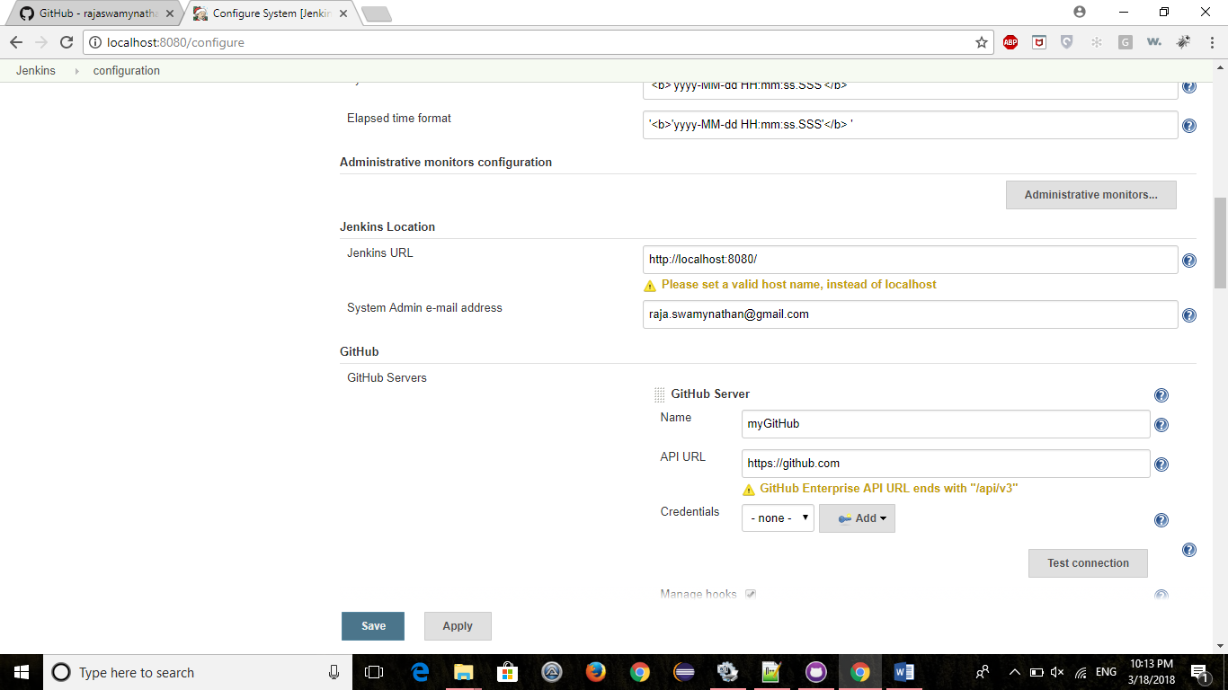

1. Goto Extented Email Notification section and enter the following info.
2. SMTP server -> smtp.gmail.com
3. Default user E-mail suffix – it should be @yahoo.com or @gmail.com
4. Default-Content Type – HTML(text/html)
5. Default recipients & Reply-To_List – Enter corresponding email addresses here

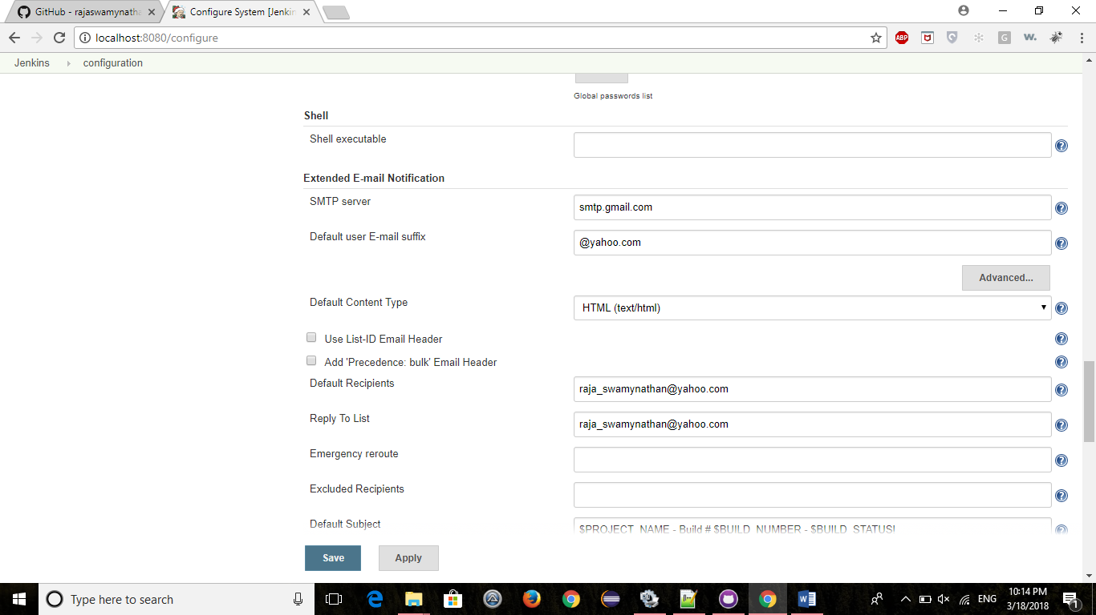

1. Goto Email Notification and enter SMTP server and Default user e-mail suffix like the info in the below picture

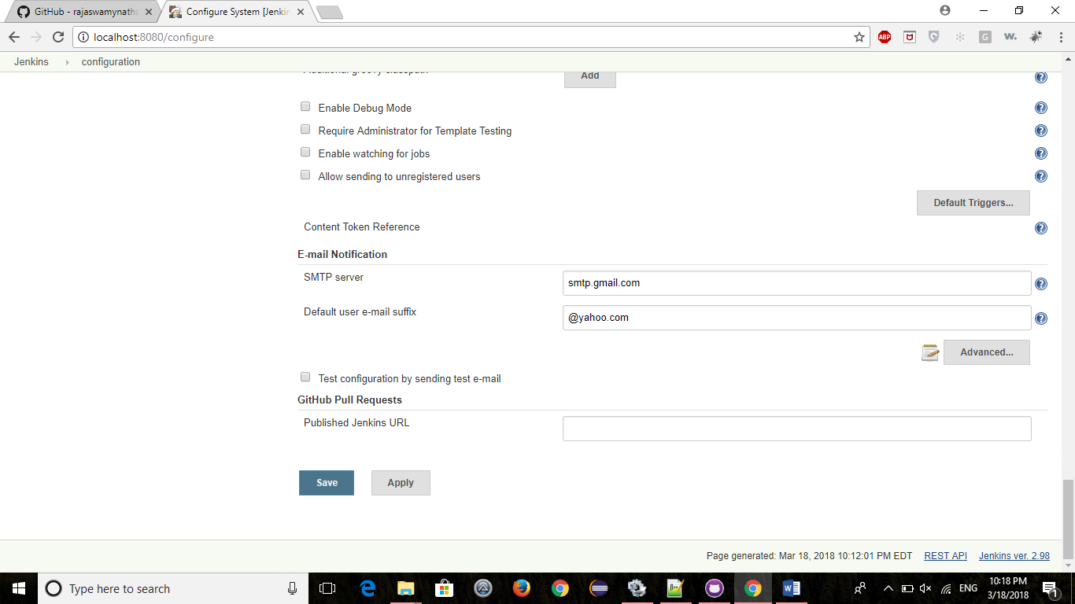

1. Click on Apply & Save button.